03 5929 2055

10 Morningside Blvd, Cranbourne West VIC 3977

[quarters.ps@education.vic.gov.au](mailto:info@quartersps.edu.au)

[www.quartersps.vic.edu.au](http://www.quartersps.vic.edu.au)

Issue 5: Thursday 3rd April 2025

Important Dates and Reminders:

|  |  |
| --- | --- |
| Friday 4th April | Gold Assembly and Easter Hat Parade 9:00am |
| Friday 4th April | Last Day of School – Students finish at 2:30pm |
| Tuesday 22nd April | First Day of Term 2 |
| Friday 25th April | ANZAC Day Public Holiday – NO STUDENTS AT SCHOOL |

A huge thank you to our local Coles for their generous donation of hot cross buns, making the final breakfast program for Term 1 extra special!

We also want to extend our thanks to Mrs Turner, Miss Hill, Mrs Cooper, Miss Willmont and Miss Baimbridge for their continued support of the program week after week. Your contributions mean so much!

Principals Message

Dear Families,

And just like that term 1 is over. A big shout out to our Prep students who have worked very hard to make it through their first term of school. Our students are tired and looking forward to their autumn/Easter break.

There has been a lot of learning and playing, making new friends and engaging in new experiences. I hope families enjoyed the opportunity to visit your child’s classroom to see their inquiry projects this term.

A thank you to all families and students who come to school ready to learn each and every day. Attendance at school is highly valued at QPS and we will follow up with families for every absence and offer support if we notice a history of absences.

QPS prides itself on high attendance rates as shown by recent data which has us with over 92% attendance and one of the highest attendance rate in the Casey South school network. We need to keep this rate high as everyday at school unless a student is unwell ensures optimum time for learning.

Term 1 ends at 2:30 pm on Friday 4th April. Please make arrangements to have your child/ren picked up at 2:30 pm.

Term 2 starts on Tuesday 22nd April at 8:50 am. The first week is only 3 days as we have public holidays on Monday 22nd April for Easter Monday and Friday 25th April for ANZAC Day.

The students will have an “in house” ANZAC Day service on Thursday 24th April. Grades will be learning about the narrative around ANZAC Day and the importance of it in Australia’s history. We will commemorate it with a acknowledgement sometime during the day. Students are encouraged to bring flowers if they wish to lay at the flagpoles.

When we return to school, hats are not required as part of the uniform. Keep your hat safe to be used again in term 4. Take the opportunity over the break to check your child’s uniform so they are clean and tidy for term 2. As the weather becomes colder in term 2, please ensure your child has the correct and appropriate uniform to wear. The school savings bonus (SSB) is available to buy new uniform.

Enjoy the autumn weather over the holiday and Easter break. Happy Easter to those who celebrate it.

Looking forward to seeing you at our Gold Assembly and Easter Hat parade on Friday.

Stay healthy, happy and safe!

Liz Davey

Principal.

Wellbeing and Inclusion News

What an amazing school community we have at Quarters Primary School!!

A big thank you to our families, students and staff for coming together to celebrate World Autism Awareness Day. By acknowledging and celebrating this day we’re working to raising awareness, sharing knowledge and developing our understanding to creating a community where individuals on the autism spectrum are celebrated for who they are.

A very special mention to our wonderful Education Support Team who looked incredible and go above and beyond every single day to support our students.

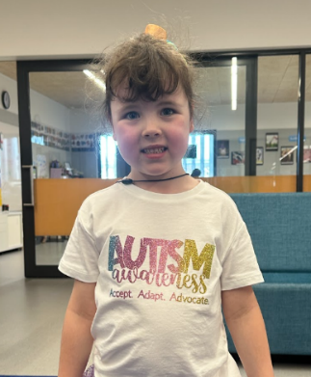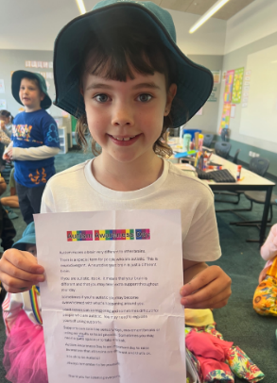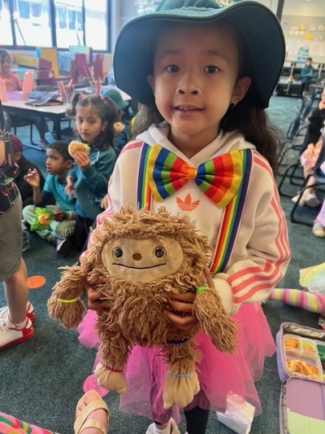

**SEL STAR Award Recipients**

Time to congratulate our SEL STAR award recipients from weeks 7 and 8. These students are being acknowledged for demonstrating our ACHIEVE values and making positive contributions to our school community.

|  |  |
| --- | --- |
| **Grade** | **SEL Star Award Recipients**  **Weeks 7 and 8** |
| **Prep A** | **Harmannat** |
| **Prep B** | **Dharsh** |
| **Prep C** | **Bhadra** |
| **Prep D** | **Mila** |
| **1/2A** | **Aryan** |
| **1/2B** | **Fatehveer** |
| **1/2C** | **Faaolaina** |
| **1/2D** | **Kevin** |
| **1/2E** | **Tegh** |
| **1/2F** | **Denzel** |
| **1/2G** | **Aviraj** |
| **3/4A** | **Fatehdeep** |
| **3/4B** | **Josh** |
| **3/4C** | **Harshitha** |
| **3/4D** | **Briell** |
| **3/4E** | **Gurseerat** |
| **5/6A** | **Neha** |
| **5/6B** | **Everyone in 5/6B** |
| **5/6C** | **Geetman** |
| **5/6D** | **Pranav** |
| **5/6E** | **Abdullah** |

|  |  |
| --- | --- |
|  | **Specialist Awards – Weeks 7 and 8** |
| **PE** | **1/2F** |
| **Visual Arts** | **1/2B** |
| **Auslan** | **No award** |
| **DigiTech** | **5/6C** |

Attendance and Uniform

Attendance Raffle Matters:

School Attendance is an important indicator of a positive school climate, the more frequently students attend school, the greater the educational, social, and emotional outcomes will be.

We are very proud of our QPS learner's resilience to continue attending school and each term we endeavour to celebrate our learners for their efforts.

Each term we draw out the names of the students who have been at school every day. Therefore, the more full weeks that students attend school, the more raffle tickets that they have in the box and the more chance that they have of winning a prize! 🌟

On Friday, 4th April at Gold Assembly, we will draw out the Attendance Raffle Winners. Thank you for all the families for their ongoing support with our attendance drive.

School Celebrations

Harmony Week is a special occasion for all Australians to celebrate cultural diversity and unity. At Quarters Primary School, we fully embrace children and families from various cultural backgrounds, recognising that diversity enriches our school community. Quarters Primary School embraced the spirit of unity and inclusivity on Friday 21st March in celebration of Harmony Day Assembly. This has become an annual event at QPS since 2023. Our learners performed a variety of acts including traditional dances, singing and storytelling, that showcased the many different cultures represented within the school community. Throughout the week, learners were engaged in classroom activities aimed at understanding and appreciating different cultural perspectives.  Learners were invited to wear their traditional cultural clothing or a touch of orange. They were excited and proud to share their cultural dress and there was a definite feeling of celebration around the school.

The assembly was opened by a couple of our students with the Welcome to Country and the Finale song was performed by the whole school in AUSLAN. Our performers worked hard over the past few weeks to prepare their acts ready. We had dances from New Zealand, Samoa, Australia, India, Philippines, and China.

It is a concert that recognises and highlights the beauty of our cultural diversity and inclusiveness at QPS.

Specialist News

Our senior students in years 5 and 6 have been studying the characteristics of Tim Burtons animation. His characters have a spooky vibe to them and the best way to portray that vibe is with black and white pencil shading. We turned our self portraits into a Tim Burton type character and had a lot of fun in the process!

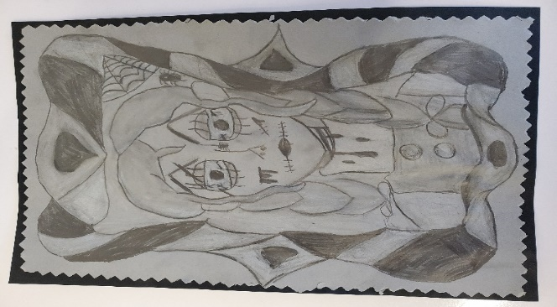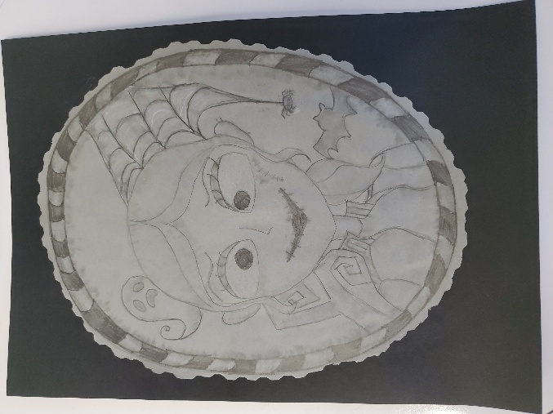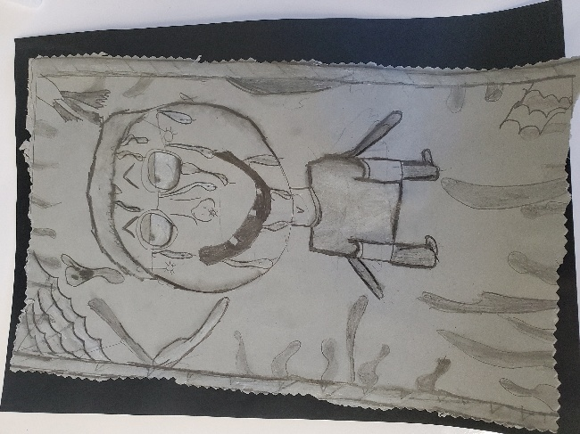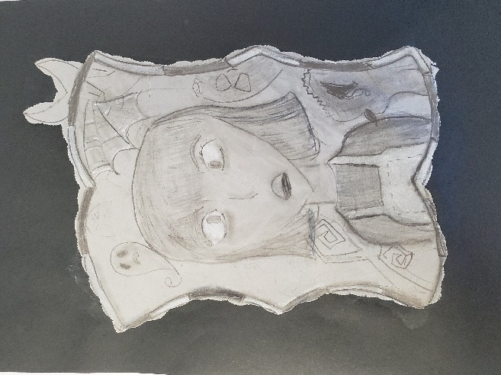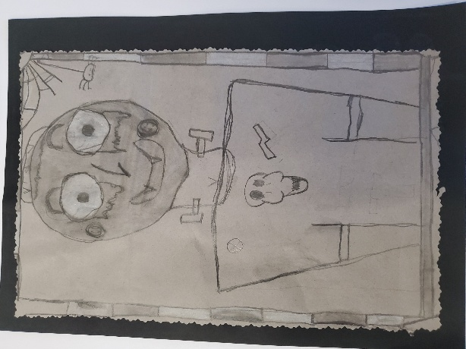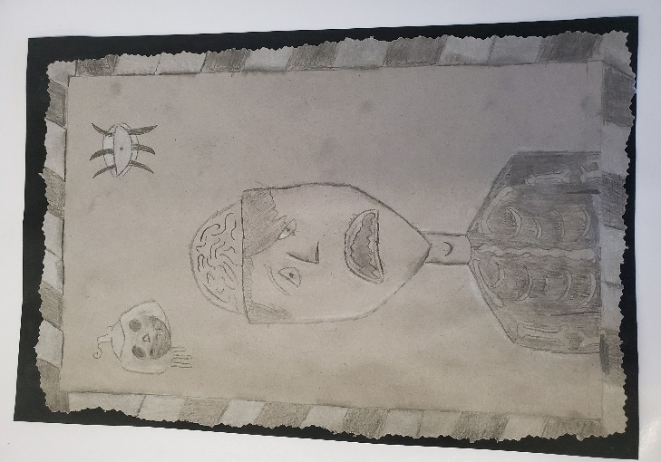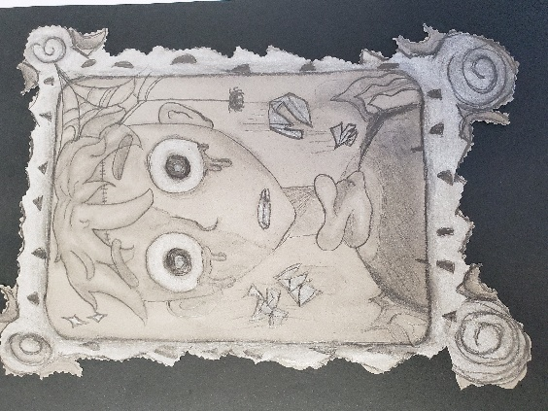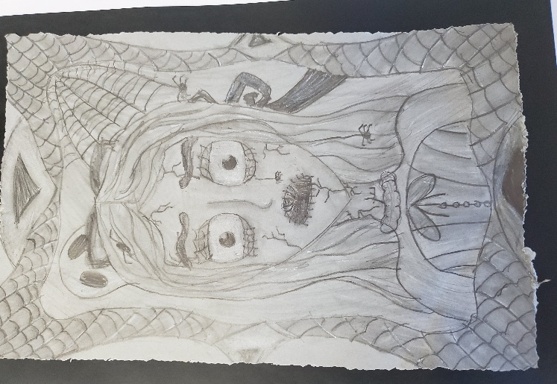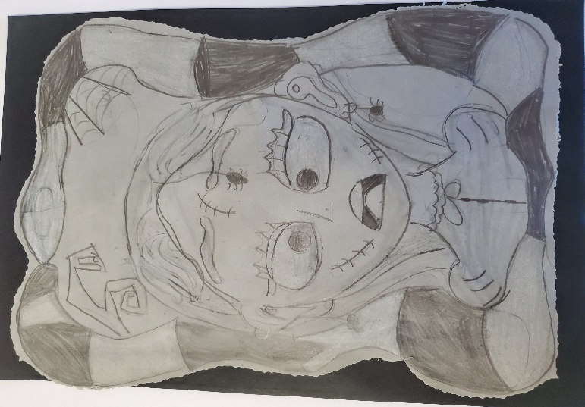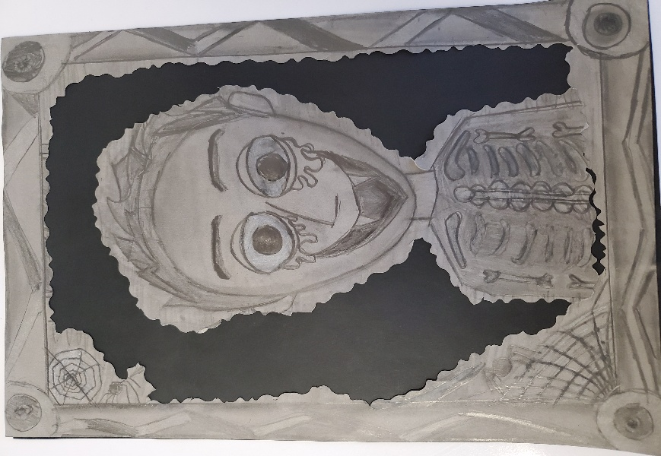

Community News



